**BANK LOAN REPORT QUERY DOCUMENT**

1. **BANK LOAN REPORT | SUMMARY**

**KPI’s:**

**Total Loan Applications**

SELECT COUNT(id) AS Total_Loan_Applications FROM bank_loan_data



**MTD Loan Applications**

SELECT COUNT(id) AS MTD_Total_Loan_Applications FROM bank_loan_data

WHERE MONTH(issue_date) = 12



**PMTD Loan Applications**  
SELECT COUNT(id) AS PMTD_Total_Loan_Applications FROM bank_loan_data

WHERE MONTH(issue_date) = 11



**Total Funded Amount**

SELECT SUM(loan_amount) AS Total_Funded_Amount FROM bank_loan_data



**MTD Total Funded Amount**

select sum(loan_amount) as MTD_Total_Funded_Amount from bank_loan_data

where month(issue_date) = 12 and year(issue_date) = 2021



**PMTD Total Funded Amount**

select sum(loan_amount) as PMTD_Total_Funded_Amount from bank_loan_data

where month(issue_date) = 11 and year(issue_date) = 2021



**Total Amount Received**

select sum(total_payment) as Total_Amount_Received from bank_loan_data



**MTD Total Amount Received**

select sum(total_payment) as MTD_Total_Amount_Received from bank_loan_data

where month(issue_date)=12 and year(issue_date)=2021



**PMTD Total Amount Received**

select sum(total_payment) as PMTD_Total_Amount_Received from bank_loan_data

where month(issue_date)=11 and year(issue_date)=2021



**Average Interest Rate**

SELECT round(AVG(int_rate),4) *100 AS Avg_Interest_Rate FROM bank_loan_data



**MTD Average Interest**

SELECT round(AVG(int_rate),4) *100 AS MTD_Avg_Interest_Rate FROM bank_loan_data

WHERE MONTH(issue_date) = 12 and year(issue_date) = 2021



**PMTD Average Interest**

SELECT round(AVG(int_rate),4) *100 AS PMTD_Avg_Interest_Rate FROM bank_loan_data

WHERE MONTH(issue_date) = 11 and year(issue_date) = 2021



**Avg DTI**

select round(avg(dti),4) * 100 as Avg_DTI from bank_loan_data



**MTD Avg DTI**

select round(avg(dti),4) * 100 as MTD_Avg_DTI from bank_loan_data

where month(issue_date) = 12 and year(issue_date)= 2021



**PMTD Avg DTI**

select round(avg(dti),4) * 100 as PMTD_Avg_DTI from bank_loan_data

where month(issue_date) = 11 and year(issue_date)= 2021



**GOOD LOAN ISSUED**

**Good Loan Percentage**

select (count(case when loan_status = 'Fully Paid' or loan_status = 'Current' then id end)* 100)/ count(id) as Good_loan_percentage

from bank_loan_data



**Good Loan Applications**

select count(id) as Good_Loan_Applications from bank_loan_data

where loan_status = 'Fully Paid' or loan_status = 'Current'



**Good Loan Funded Amount**

select sum(loan_amount) as Good_Loan_Funded_Amount from bank_loan_data

where loan_status = 'Fully Paid' or loan_status = 'Current'



**Good Loan Amount Received**

select sum(total_payment) as Good_Loan_received_Amount from bank_loan_data

where loan_status = 'Fully Paid' or loan_status = 'Current'



**BAD LOAN ISSUED**

**Bad Loan Percentage**

SELECT

(COUNT(CASE WHEN loan_status = 'Charged Off' THEN id END) * 100.0) /

COUNT(id) AS Bad_Loan_Percentage

FROM bank_loan_data



**Bad Loan Applications**

SELECT COUNT(id) AS Bad_Loan_Applications FROM bank_loan_data

WHERE loan_status = 'Charged Off'



**Bad Loan Funded Amount**

SELECT SUM(loan_amount) AS Bad_Loan_Funded_amount FROM bank_loan_data

WHERE loan_status = 'Charged Off'



**Bad Loan Amount Received**

SELECT SUM(total_payment) AS Bad_Loan_amount_received FROM bank_loan_data

WHERE loan_status = 'Charged Off'



**LOAN STATUS**

SELECT

loan_status,

COUNT(id) AS LoanCount,

SUM(total_payment) AS Total_Amount_Received,

SUM(loan_amount) AS Total_Funded_Amount,

AVG(int_rate * 100) AS Interest_Rate,

AVG(dti * 100) AS DTI

FROM

bank_loan_data

GROUP BY

loan_status

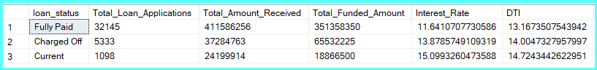

SELECT

loan_status,

SUM(total_payment) AS MTD_Total_Amount_Received,

SUM(loan_amount) AS MTD_Total_Funded_Amount

FROM bank_loan_data

WHERE MONTH(issue_date) = 12

GROUP BY loan_status

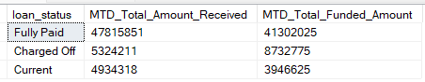

**BANK LOAN REPORT | OVERVIEW**

**MONTH**

SELECT

month(issue_date) as month_number,

DATENAME(MONTH, issue_date) AS Month_name,

COUNT(id) AS Total_Loan_Applications,

SUM(loan_amount) AS Total_Funded_Amount,

SUM(total_payment) AS Total_Amount_Received

FROM bank_loan_data

GROUP BY month(issue_date),DATENAME(MONTH, issue_date)

ORDER BY month(issue_date)

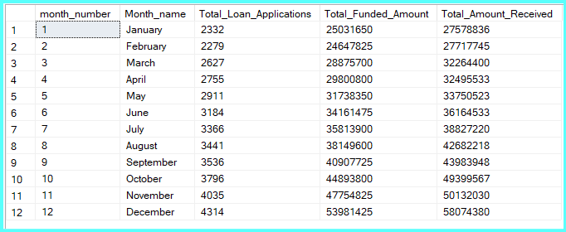

**STATE**

SELECT

address_state,

COUNT(id) AS Total_Loan_Applications,

SUM(loan_amount) AS Total_Funded_Amount,

SUM(total_payment) AS Total_Amount_Received

FROM bank_loan_data

GROUP BY address_state

ORDER BY count(id) desc

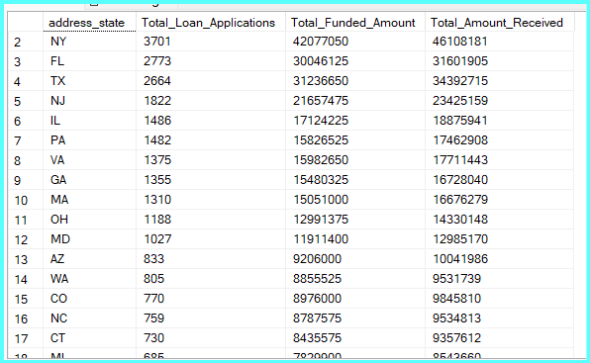

**TERM**

SELECT

term,

COUNT(id) AS Total_Loan_Applications,

SUM(loan_amount) AS Total_Funded_Amount,

SUM(total_payment) AS Total_Amount_Received

FROM bank_loan_data

GROUP BY term

ORDER BY term

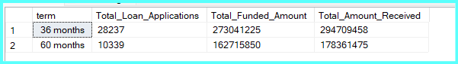

**EMPLOYEE LENGTH**

SELECT

emp_length AS Employee_Length,

COUNT(id) AS Total_Loan_Applications,

SUM(loan_amount) AS Total_Funded_Amount,

SUM(total_payment) AS Total_Amount_Received

FROM bank_loan_data

GROUP BY emp_length

ORDER BY emp_length

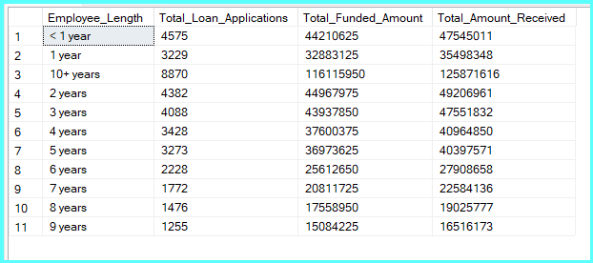

**PURPOSE**

SELECT

purpose AS PURPOSE,

COUNT(id) AS Total_Loan_Applications,

SUM(loan_amount) AS Total_Funded_Amount,

SUM(total_payment) AS Total_Amount_Received

FROM bank_loan_data

GROUP BY purpose

ORDER BY count(id) desc

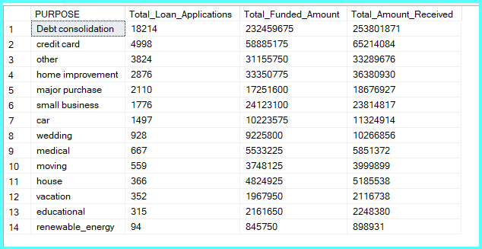

**HOME OWNERSHIP**

SELECT

home_ownership AS Home_Ownership,

COUNT(id) AS Total_Loan_Applications,

SUM(loan_amount) AS Total_Funded_Amount,

SUM(total_payment) AS Total_Amount_Received

FROM bank_loan_data

GROUP BY home_ownership

ORDER BY count(id) desc

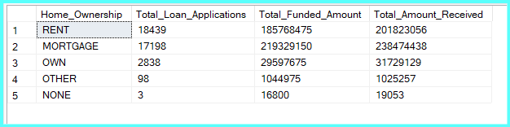

*See the results when we hit the Grade A in the filters for dashboards.*

*SELECT*

*purpose AS PURPOSE,*

*COUNT(id) AS Total_Loan_Applications,*

*SUM(loan_amount) AS Total_Funded_Amount,*

*SUM(total_payment) AS Total_Amount_Received*

*FROM bank_loan_data*

*WHERE grade = 'A'*

*GROUP BY purpose*

*ORDER BY purpose*